ICS2240

GROUP ASSIGNMENT.

Names. REG.NO

1.SERENA WEKESA HSB212-0034/2022

2.SHIRLEY OUMA HSB212-0041/2022

3.VICTOR NJUE HSB212-0499/2022

LIPOPROTEINS.  
Lipoproteins are complex molecular structures in the blood that consists of proteins and lipids and play a crucial role in the transportation of lipids in the bloodstream.

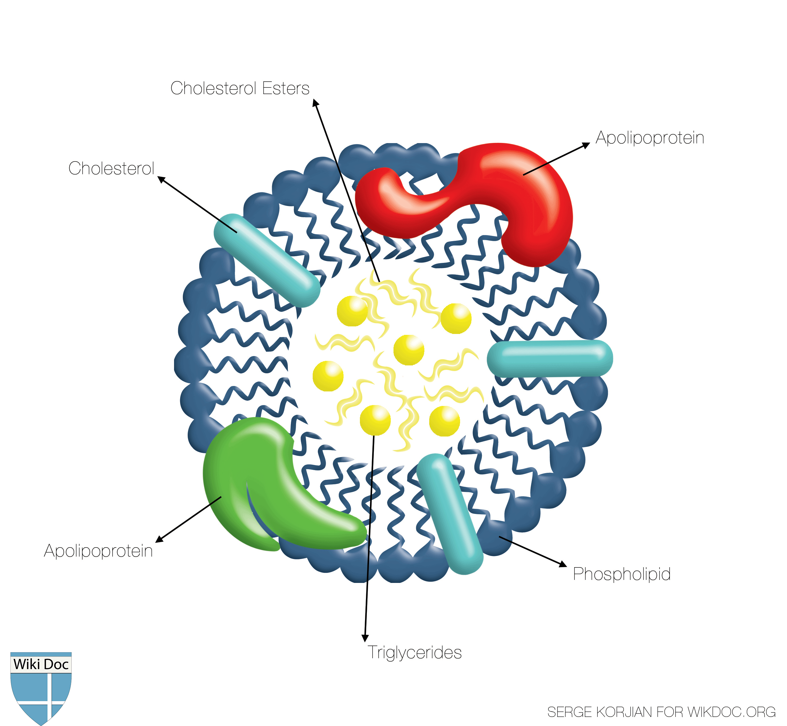

Lipoproteins are several carrying out different functions.

Lipoproteins include:

1. Chylomicrons
2. Very low density lipoproteins
3. Low density lipoproteins
4. High density lipoproteins

1.Chylomicrons

Large lipoproteins that transport triglycerides from intestines to the cells

2.Very low density lipoproteins(VLDL)

These particles transport triglycerides from the liver to the cells. Once they lose the triglycerides they form intermediate density lipoproteins

3.Low density lipoproteins(LDL)

LDL particles carry cholesterol from the liver to the cells. Presence of excess LDL cholesterol in the bloodstream can deposit in the walls of the arteries causing atherosclerosis.

4.High density lip s(HDL)

HDL particles help remove cholesterol from the bloodstream by transporting it back to the liver

|  |  |  |
| --- | --- | --- |
| Class | Diameter(mm) | Source and function |
| Chylomicrons(Cm) | 500  largest | Intestine ,Transport of dietary TAG |
| Very low density lipoproteins(VLDL) | 43 | Liver. Transport of endogenously synthesized TAG |
| Low density lipoprotein(LDL) | 22 | Formed in circulation by partial breakdown of IDL. Delivers cholesterol to peripheral tissues. |
| High density Lipoprotein(HDL) | 8  Smallest | Liver, Removes “used” cholesterol from tissues and it takes it to the liver.  Donates apolipoproteins to CM and VLDL |